**Question #1**

Personal Web Page Generator Write a program that asks the user for his or her name, then asks the user to enter a sentence that describes himself or herself. Here is an example of the program’s screen:

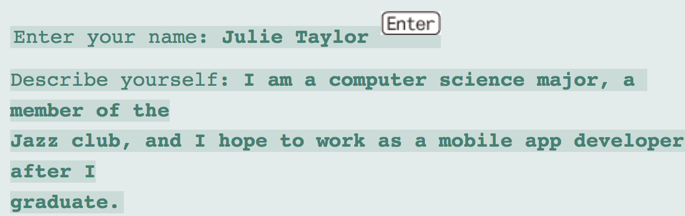

Enter your name: Julie Taylor Describe yourself: I am a computer science major, a member of the Jazz club, and I hope to work as a mobile app developer after I graduate. Once the user has entered the requested input, the program should create an HTML file, containing the input, for a simple Web page. Here is an example of the HTML content, using the sample input previously shown:

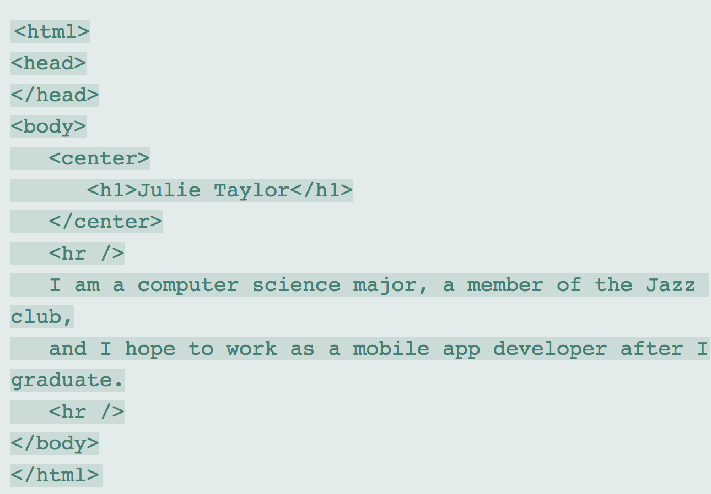

**Question #2**

Using notepad, TextPad, or any other text editors, create a text file with the following data shown below, without the headings.

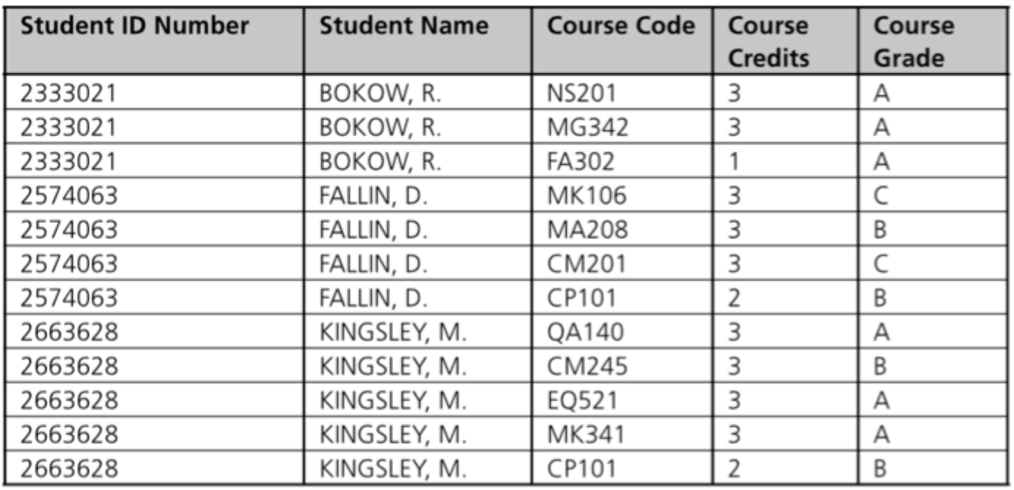

Write a program that creates student grade reports. Save the report in a file separate filename. The grade report for each student should contain the student’s name and ID number, a list of courses taken, the credits and grade for each course, and a semester grade point average (GPA). For example, this is the grade for the first student:

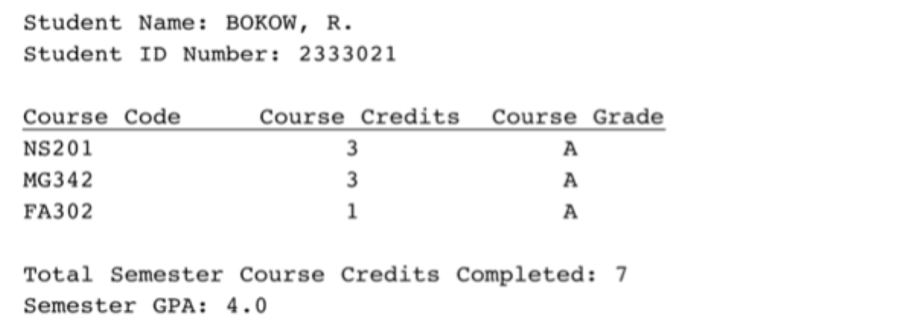

The semester GPA is computed in two steps. First, each course grade is assigned a numerical value (A=4, B=3, C=2, D=1, F=0), and the sum of each course’s grade value times the credits for each course is computed. The sum is then divided by the total number of credits taken during the semester.

Submit your program file and your saved report file above.